In order to identify the attitude of Russian tweets, we have done sentiment analysis of Russian tweets using four approaches. In each of them, the texts were categorised into 3 classes which are: Negative, Neutral, and Positive.

In the first approach, we extracted 1455 Russian texts from the dataset and translated the unique ones. They are all analyzed by the VADER lexicon sentiment analysis. Each text fall into the classes: Negative, Neutral, and Positive. As presented in Table 1, we found the majority of tweets were classified as negative and almost equal proportions were classified as Neutral and Positive. Each of them did not reach half of negative tweets.

**Table 1:**

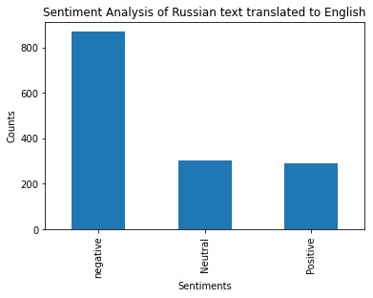

In the next approach we applied another sentiment analysis library: Dostoevsky package on Russian texts and categorised texts into the same classes as in the first approach. Table 2 presented that majority of tweets were classified as Neutral. Positive and negative tweets did not reach half of neutral ones and they almost took equal proportion.

**Table 2:**

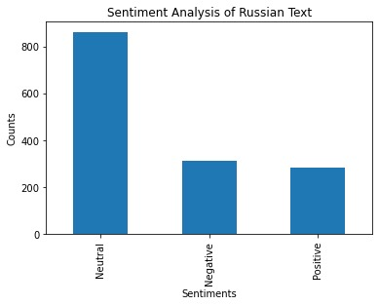

Next, refactoring the source code for VADER sentiment lexicon was performed for Russian language. In this approach we extracted the words list from the VADER sentiment lexicon and translated them to Russian assuming that the intensity rating will be consistent after translation. After updating the intensity rating for all the English words to corresponding Russian ones, we run the same code to calculate the sentiment intensity for Russian text. The result can be seen in table 3. We didn’t get the expected outcome, but our results were similar to the results obtained from the second approach using Dostoevsky library.

**Table 3:**

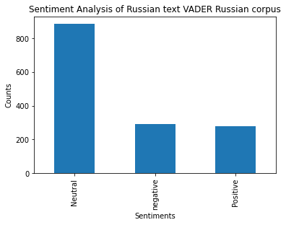

Finally, Rubert model was performed in the sentiment analysis. In this approach, we applied Fine-tuned Multilingual Encoder, Rubert, and Multilingual Universal Sentence Encoder for the sentiment classification in Russian text1. The categorization is the same as the previous ones: Neutral, positive, and negative. As presented in Table 4, we found negative tweets take the majority, which is similar with the result of translating Russian to English. Thus, the outcome produced by performing Rubert transformer model is the most ideal for our sentiment analysis.

**Table 4:**

Citation:

1 “Sentiment-analysis-in-russian: Fine-tuned multilingual Bert and multilingual use for sentiment analysis in Russian. Rureviews, Rusentiment, Kaggle Russian news dataset, LINIS crowd, and RuTweetCorp were utilized as training data.” Sismetanin. (Issue 2021).